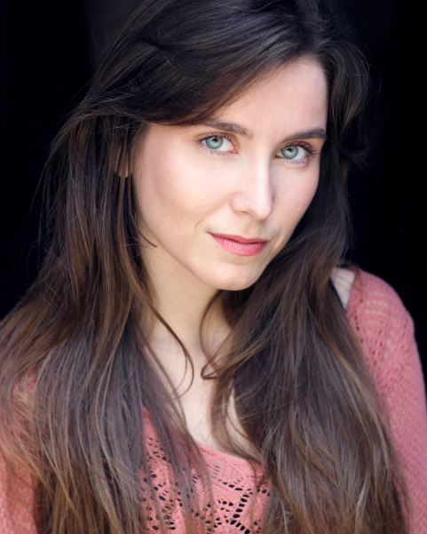
Núria Calucho Juncà

Email: airuncj@msn.com
Playing age: 23 – 30
Phone 07429026320

Stage Credits:
2021 Online performance. THE BACTERIAL LEISURE CENTRE. Entertainer. University College of London. Directed by La Facciocose

2020, Stage. One-woman show. Comedy. FEAR. Written and directed by Nuria Calucho. Performed at The Lewes Festival of one-woman show and The Cockpit Theatre.

2018 Stage. Earthquakes. City Academy Theatre Company. Little Angel Theatre, London.

2016 Stage. Lead, Mary Liesching. THE LAST WALTZ. Bruno Matay. The Rosendale pub.

2013, Stage. Lead. SWEET NOTHING, Eduard Muntada. Tour around Catalunya, Tremp.

2012, Immersive Theatre. Multiple characters. FERRO COLAT. Directed by Josep Rodri. Fira de Tarrega, Spain.

Film Credits
2021 Film. Memento Mori. Lead. The London Film School. Directed by Michelle Alise
2018 Presenter for Cambridge Online Language Learning Website. Directed by David Holloway
2018 Short film. Laura Parker, FIRST DATE. Sheridian Films.
2017 Short Film, Lola, THE PILL. University of Westminster of film and TV. Directed by Aline Soares.
2015, Short Film 69, Amalia. Directed by Adele Faldetta. University of Westminster of film and TV.
TV Commercials
2021 MUTUA MADRILEÑA. Directed by Marc Corominas. Blur Film Productions.
Presenter
2019, Corporate, Presenter, Sodexo P&G Studio shoot, Interlink, Paul Lucas.

2018 . Presenter. Inside IELTS Cambridge exams. Directed by Thomas Booth.

Still photography
2018, Still Photography, Model / Front Cover Feature Magazine, An Essex Wedding Magazine, Jennie Galgey

Role Play
2015, Role Play, Patient, ROLE PLAY FOR EXAMINATIONS, Royal College of Obstetricians and Gynaecologists, Paul Caister.

Languages
Skills:

- Physical Theatre
- Clowning
- Comedy
- Vocal range C to E
- Driving
- Sketch writer

*Catalan, Spanish and English

Accents:

- Italian
- Russian/ Eastern European.

Education
The Poor School, Performing Arts, London.
The Royal Central School of speech and drama.
Physical Theatre, La Facciocose, Theatre Deli
Music School, Orfeó de Lleida.
Violin and piano to an intermediate level.
MA in Research
MA in Educative Psychology
BA Primary Teacher

